Ceng311: Web Technology Applications

Ankara Yildirim Beyazit University

25/03/2021

Lecturer: Dr. Fadi Yilmaz

Student: Cemil Uysal

No: 16050111006 Homework#1

**Interactive Web Application Requirements and Design**

Develop/Extend a web application for a community group to encourage communication about activities and projects.

Categories of Users:

* Spectator Movie User
* Spectator Series User
* Reader User

Existing Web Pages:

* <https://www.imdb.com/>
* <https://www.goodreads.com/>

Imdb web page allows the user taking a list of are watched movies or series.

Goodreads page allows the user give comments the book and taking a list of are read books.

**Requirements and Design Document:**

**Project Overview:**

People can discover new movies, series or books. And also, people sign an account and taking list of is read book or is watched movie, or series. And also, people see their friend’s comments and see their list. So, they will read or watch it. My target market is people who likes reading book or watching movie and series.

**Site Map:**

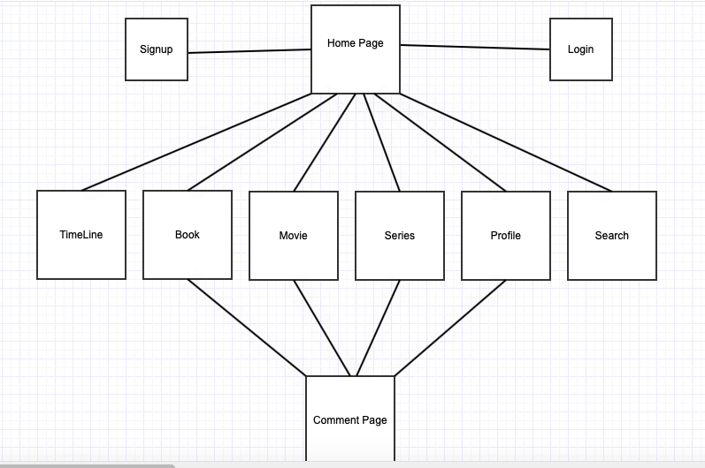

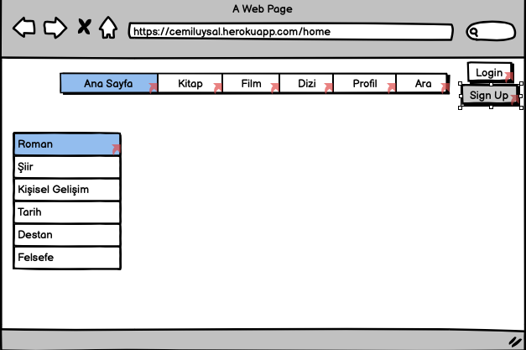

* Home Page
* User can investigate movies, series, books.
* User may login or sign up. User can search Movies, series, books.
* If a user login the account, the user sees his/her profile and the page that that showing friends comments.

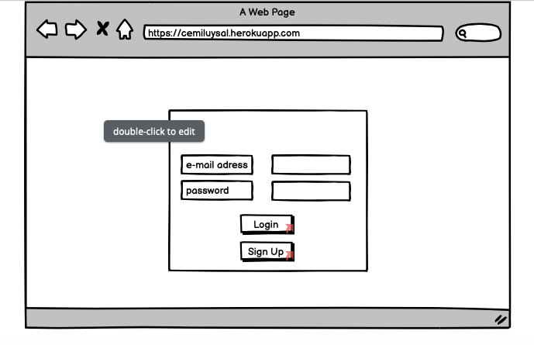

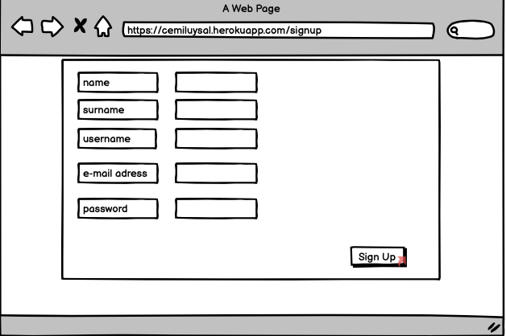

* Login or Signup page
* User can create account and login this account.

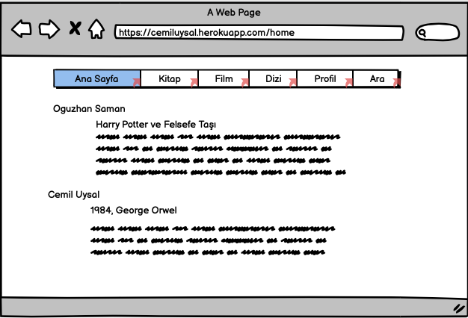

* Timeline
* User may see his/her friend’s comments, and name of movies, series or books name.

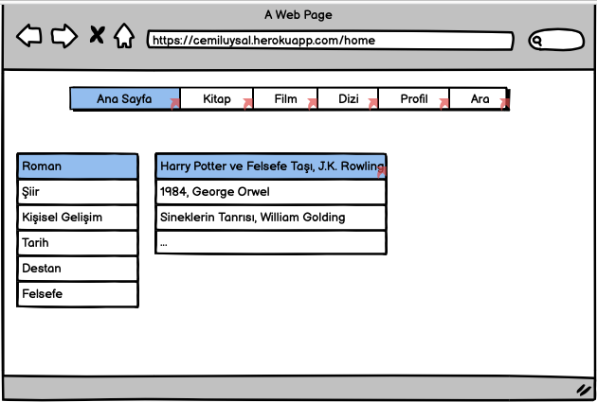

* Books
* User can see type of books.
* User can see books.
* User can reach the comment of any books.

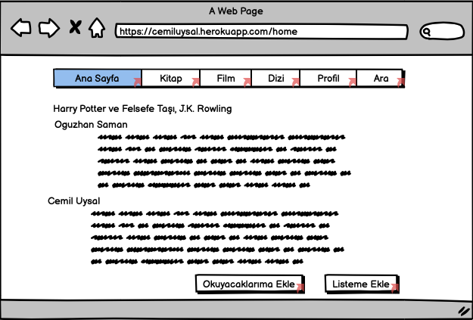

* One of Book page
* User can see comment of a chosen book.
* User can add this book own done list or will do list.

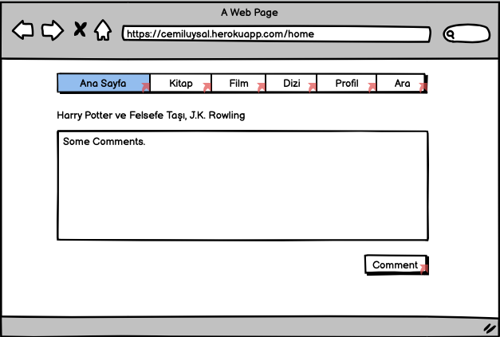

* Comment Page
* User can add comment a chosen book. And this comment and this book are also added own timeline.

And also, this web site has movies and series page, they look like books page.

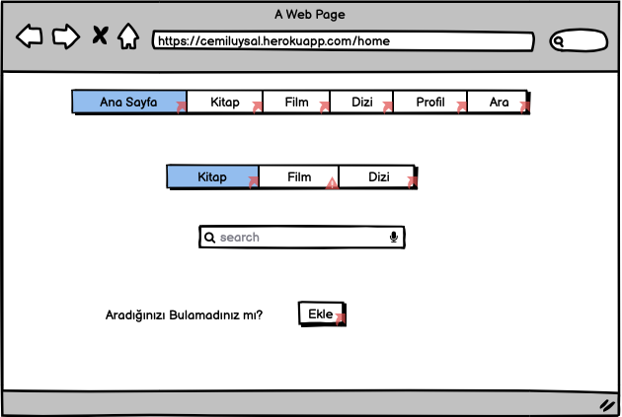

* Search Page
* People search a book, movie or series.
* People also add a new book, movie or series.

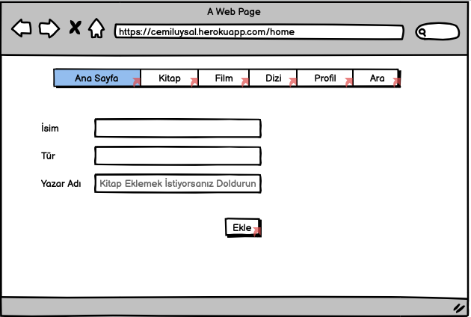

* Adding page
* People have to enter name of the movie, series or book name.
* People have to enter type of the movie, series or book name.
* If People wants to add a new book, they must enter author of the book.

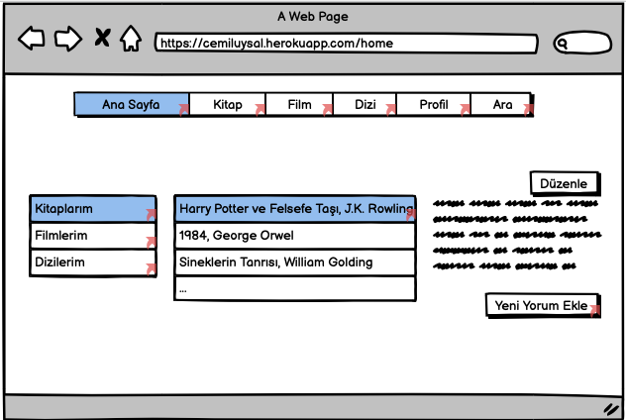

* Profile page
* People can see list of books, movies, or series.
* People can update their comments.
* People can add new comments a chosen books or movie or series.

<https://balsamiq.cloud/s5i5xyk/p3imn8q/rB76D>

**Dynamic Functionality:**

I don’t find a dynamic functionality. I will update this report, If I find it.